Day03 - Task01 - Linux Commands

- pwd - This command is used to know the ‘present working directory’.
- cd - This command is used to ‘change the directory’
2.1 cd .. - is used when we want to go to the previous directory
2.2 <directory name> - changes to the specified directory
- ls - This command is used to know the list of items in the directory
3.1 ls -a - Lets us know the list of files and folders along with hidden items
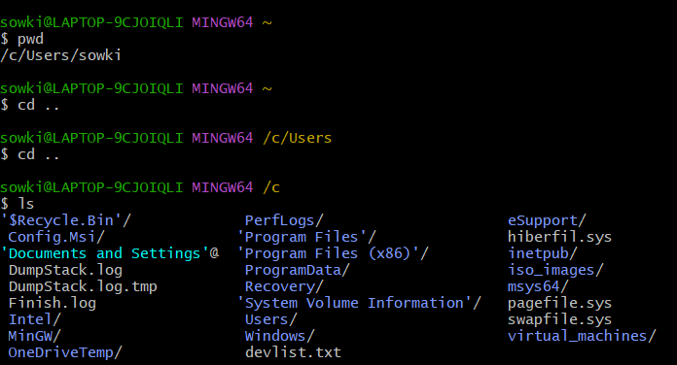
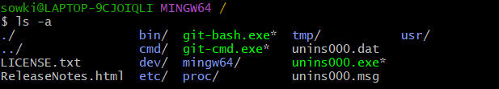

- ll - This command is used to know the detailed lists of files and directories
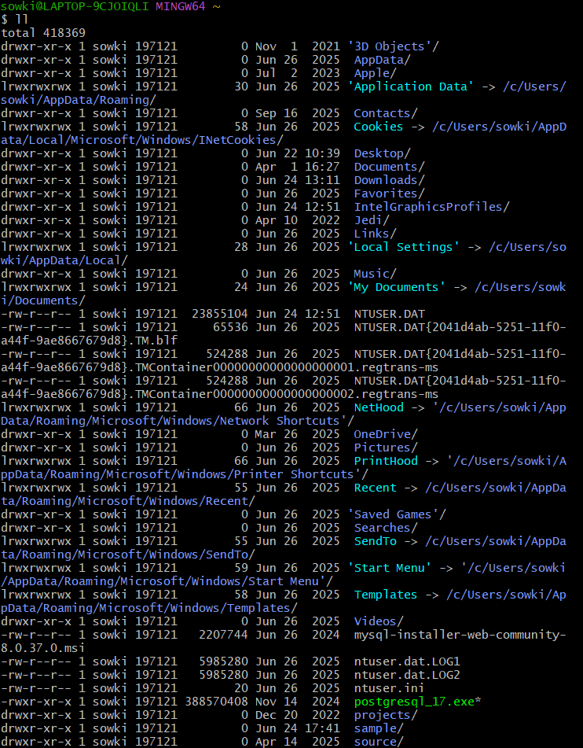

- mkdir - ‘make a directory’ This command is used when we want to create a new directory.
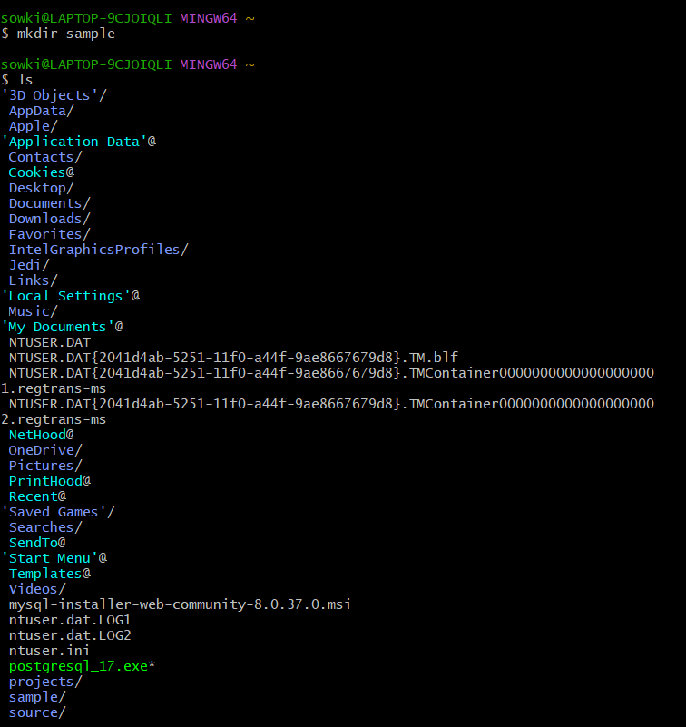

- rm -rf - This command is used to remove a directory
- find - This command is used to search anything in the present working directory
- touch - This command is used to create a new file
- rm - This command is used to remove a file
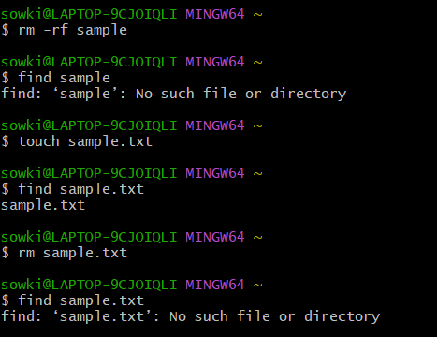

- vi - This command is used to create a new text file and open the editor for editing
10.1 <0/INSERT> - Should be used to insert text/modify the content
10.2 CTRL + C - To come out of the insert mode
10.3 <:wq> - Should be used to save the edits and exit
10.4 <:qa!> - Should be used to abandon the file without saving
- cat - Command to view/read the contents of the text file
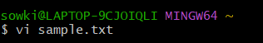
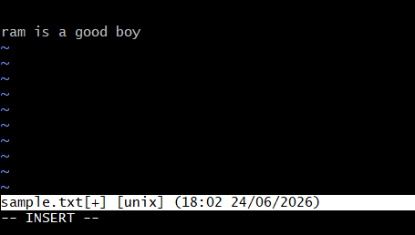
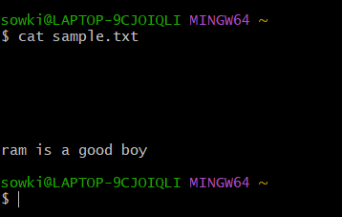

- date - Command to know the date, time and timezone
